Reset Token

🔁 What Is a Reset Token?
# Source: AI Source: Provided by: [Data Path: Persons Table -> ID Column: 1, Name_En Column: Motasem Essam] -> From: [ChatGPT] on [1/18/2026]
A Reset Token is a temporary, unique, secret string that is generated when a user requests to reset their password (or perform another sensitive action). It’s sent to the user (usually by email) and is required to verify their identity before allowing them to continue.

✅ Simple Definition:
# Source: AI Source: Provided by: [Data Path: Persons Table -> ID Column: 1, Name_En Column: Motasem Essam] -> From: [ChatGPT] on [1/18/2026]
A Reset Token is a one-time code or link used to securely let someone reset their password or verify account ownership.

🧠 Real-Life Analogy:
# Source: AI Source: Provided by: [Data Path: Persons Table -> ID Column: 1, Name_En Column: Motasem Essam] -> From: [ChatGPT] on [1/18/2026]
Think of a password reset token like a temporary door key:
- It works only for you
- It only works once or for a short time
- If someone else finds it, they can break in — so it must be protected

🔁 Common Reset Token Flow:
# Source: AI Source: Provided by: [Data Path: Persons Table -> ID Column: 1, Name_En Column: Motasem Essam] -> From: [ChatGPT] on [1/18/2026]
- 👤 User clicks “Forgot Password”
- 📩 Server generates a secure reset token
- ✉️ Server sends an email with a reset link, e.g
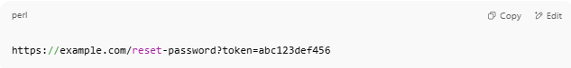
https://example.com/reset-password?token=abc123def456

- ✅ User clicks the link → enters new password
- 🔐 Server checks if the token is valid and not expired
- 🔁 If valid → password is reset, and the token is destroyed

🔐 Reset Token Characteristics:
# Source: AI Source: Provided by: [Data Path: Persons Table -> ID Column: 1, Name_En Column: Motasem Essam] -> From: [ChatGPT] on [1/18/2026]
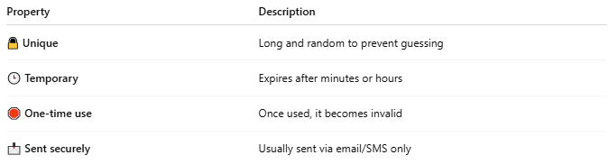

Property | Description
🔒 Unique | Long and random to prevent guessing
🕒 Temporary | Expires after minutes or hours
🛑 One-time use | Once used, it becomes invalid
📩 Sent securely | Usually sent via email/SMS only

🛠 Example Reset Token (PHP-style)
# Source: AI Source: Provided by: [Data Path: Persons Table -> ID Column: 1, Name_En Column: Motasem Essam] -> From: [ChatGPT] on [1/18/2026]
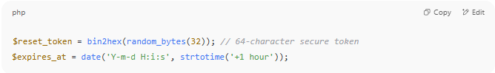

$reset_token = bin2hex(random_bytes(32)); // 64-character secure token
$expires_at = date('Y-m-d H:i:s', strtotime('+1 hour'));

🗂 Stored in Database Like:
# Source: AI Source: Provided by: [Data Path: Persons Table -> ID Column: 1, Name_En Column: Motasem Essam] -> From: [ChatGPT] on [1/18/2026]
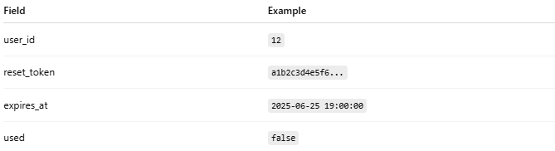

Field | Example
user_id | 12
reset_token | a1b2c3d4e5f6...
expires_at | 2025-06-25 19:00:00
used | false

⚠️ Reset Token Security Tips
# Source: AI Source: Provided by: [Data Path: Persons Table -> ID Column: 1, Name_En Column: Motasem Essam] -> From: [ChatGPT] on [1/18/2026]
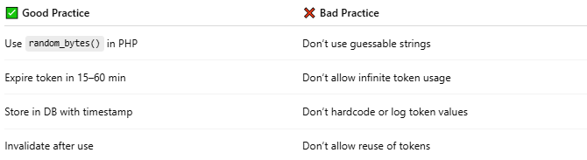

✅ Good Practice | ❌ Bad Practice
Use random_bytes() in PHP | Don’t use guessable strings
Expire token in 15–60 min | Don’t allow infinite token usage
Store in DB with timestamp | Don’t hardcode or log token values
Invalidate after use | Don’t allow reuse of tokens

🔒 Where Are Reset Tokens Used?
# Source: AI Source: Provided by: [Data Path: Persons Table -> ID Column: 1, Name_En Column: Motasem Essam] -> From: [ChatGPT] on [1/18/2026]
- Password reset links
- Email address verification
- Phone/email change confirmation
- 2FA recovery steps
- Account reactivation

